A Reader’s Companion to Parked
by Danielle Svetcov

Dear Readers,
Are you stuck at home, right now? Me, too. I can hear the laundry spinning in the dryer and smell overripe bananas piled on the kitchen counter. I’m spending a lot of time looking out the window, too, because I’d really like to go outside and talk to people. But I’m not supposed to. Which is weird. Really weird.
I recommend staring out your front window if you haven’t lately. Weird times or not, a window facing the street is usually a decent source of entertainment, especially if you’re sick of screens and your eyes need to stretch a little. Look long enough and you might see a new family moving in across the street. That family might have a kid about your age who could become your new best friend. In my book, PARKED, that’s exactly what happens—but, there’s a wrinkle: the new kid across the street is moving into a van…and she doesn’t much like it…and she’d rather you not look…
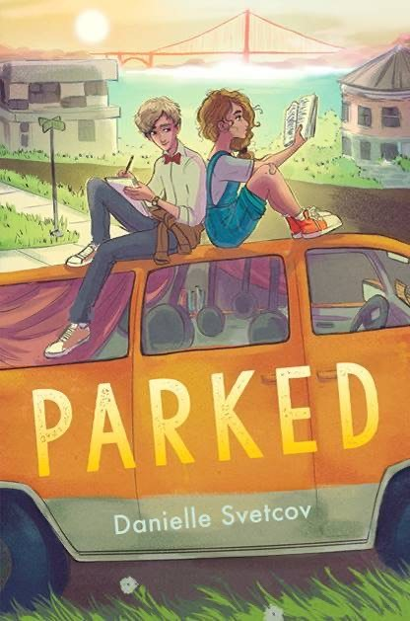
So, let me rewind. My name is Danielle Svetcov, and for the next few pages, I’m going to talk about PARKED and myself. Along the way, I’m going to ask you some questions—you will find them in bold ink. Some of the questions are quickies, gut-checks, and some—especially at the end—ask you to really dig deep (particularly if you’re using PARKED and this companion as part of a classroom exercise or project). When you reach a question, stop and answer it—out loud—even if no one is listening but you. After years of working alone in my office, I have learned that talking out loud to myself can be kinda fun. You won’t be afraid to say what you feel. You may even crack yourself up…
Okay, here we go.
So, PARKED is my first novel. I wrote it at night and on weekends. I couldn’t write during the week, because I had (still have) a full-time job. I am a literary agent. Most people have never heard of this job. A literary agent represents writers and sells their books to publishers. The authors of Harry Potter, Dog Man, Wimpy Kid, Wonder—they all had literary agents, like me, who marched their books into publishing houses and said to editors: “My client is a genius, now give her a million bucks and publish her book—otherwise, I’m going to sell her words to someone else!” That’s what I do for a living most days: brag about my authors and ask for money. I don’t usually write novels. I don’t usually talk about myself.
So, becoming a novelist who talks about her book and herself is a big change for me. But I had to do it. Because PARKED has been brewing inside me basically my whole life.

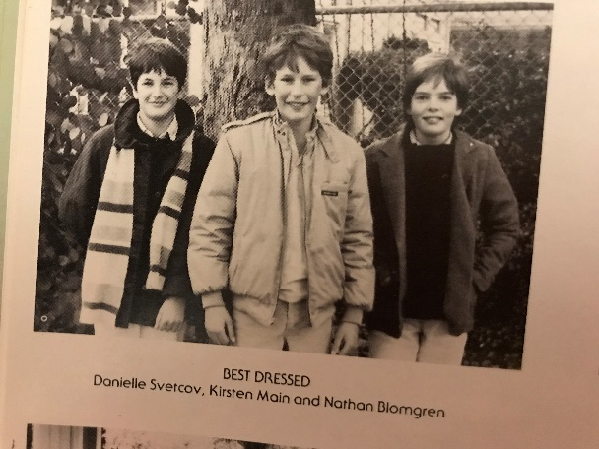
Here’s a picture of me from my sixth-grade yearbook. Even in this shot, PARKED was already brewing—I just didn’t know it yet…
I grew up in a small town in California near San Francisco. I had a pretty great childhood. My last name—Svetcov—got me teased from time to time, but nothing too bad. Any of you have two V’s in your last name, like me? Two Z’s? Q’s? Congratulations. A chewy last name is something to be proud of. But, really, I had it good. My parents loved me, I had good friends, I felt safe. In the picture above, you can see I was voted best dressed, which is funny because my mom dressed me, so the award really goes to her. The only thing that bothered me back then was my worrying: I worried about everything. I worried about getting bad grades (I never did; I was valedictorian of my middle school and high school). I worried about my appearance (it never helped). And, related to PARKED, I worried every time I saw a sad-eyed and hungry person wandering the street, looking like he or she had no place to call home. I remember adults saying, “Don’t look, Danielle,” and “it” would never happen to me. But this didn’t make my worry go away. Why would “it” happen to anyone, I wondered. And why did they say “it” like that?
Fast-forward several decades—I was living in San Francisco, studying to become a writer. For free exercise, I would walk the city’s hills, anywhere they might take me. One of my favorite walks began at my apartment in Noe Valley and ended in the Marina. It was an epic walk. The last quarter mile was like something out of a movie. From the mansions at the top of Steiner Street, down into the valley below, straight to the Bay, this is what you’d see:
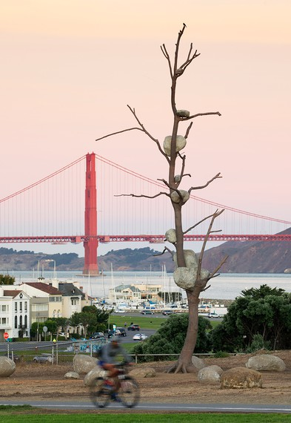
Have you ever seen this view?
Well, right in the part of the picture where land meets Bay, I would pass a line of vans with the best views of the bridge and hills and sky. These vans were clearly more than transportation. They were homes. I passed the same ones every week, in the same spots. They had laundry lines strung between them. They had TV antennae taped to their roofs. And they had better views of the Bay than the giant houses towering over them. And I wondered: What is it like to wake up to something so beautiful but to see it out of the cracked windshield of a rusting van? And then I wondered: Who lives in these vans and what circumstances brought them here? And then I wondered: What’s it like to live in a van? And then I wondered: What would happen if a family was forced to live in a van? And then I wondered: Who else might be wondering these things? And, then I looked over my shoulder at the three-story houses across the street, and I thought: What if there’s a kid in one of those houses who looks over this scene every day and decides he has to do something about it? (And what if that something is the wrong thing?)
It was on those walks that the threads for PARKED began to come together. The kid in me who needed way more information about everything started having a detailed conversation with the adult me on the subject. And then the conversation turned into a story. And the story turned into PARKED.
It only took me about 17 years, give or take, to write PARKED. Which is why it’s so thick—400 pages. I probably threw away 3,000 pages to end up with just these 400. Despite my experience with books—reading them, editing them, selling them—the experience of writing PARKED made me feel very very very dumb at times. Like I was failing. I have played the cheerleader role for many writers, but I was not particularly good at that job for myself. And then, at some point, failure—the theme of failure and overcoming it—began to sneak into my book. And, strangely, that’s when the pages started to get good.
So, here’s the basic set-up of PARKED:
There are two main characters, a boy and a girl, both twelve. It’s the summer before they start seventh grade. The girl, Jeanne Ann, has driven out to San Francisco from Chicago with her mom, who has a dream of starting her own restaurant and escaping her messy past back in the Windy City (a.k.a. Chicago). The only thing Jeanne Anne and her mom know for sure is that they must live near the Golden Gate Bridge. They want to be inspired by it. So that’s where they park, where land meets sea, practically in the bridge’s shadow. They figure it’s a temporary waystation—like camping—until Jeanne Ann’s mom finds a job and an apartment, and that won’t take long, they think…
Enter Cal. Cal lives in a giant house across the street from Jeanne Ann and her mom. He would like to save them from living in their van for all of seventh grade. Cal also has a little bit of a crush on Jeanne Ann. But you guys wouldn’t know anything about crushes…
Cal’s awkward but valiant, like a knight whose shoes are always untied. He assumes (wrongly) that everyone wants to be saved. Jeanne Ann is wise but prickly—like a goalie who’d rather play without the rest of the team. She wants her life to return to normal: school, books, candy from kindly librarians, the freedom to bicycle anywhere. She needs a friend, not a babysitter who wants to play hero. Cal doesn’t get it; he wants to make her his project. While they dance around each other, Jeanne Ann’s food starts to run out and parking enforcement officers start issuing parking tickets she and her mom can’t afford. The police threaten to tow the van. If the van is towed, Jeanne Ann will have no place to live.
There’s no doubt that Jeanne Ann and her mom spend a solid chunk of PARKED feeling like failures, even though it’s mostly bad luck that derails their plans. But sometimes that’s all failure is: Bad. Luck.
Nobody likes to fail. Nobody even likes the words “fail” or “failure.” Say “failure” a few times. It doesn’t even feel good in the mouth. For me, it sends a funny feeling through my jaw. Failure. Failure. Failure. Failure. Failure. Failure. Ech.
I’ve given the topic of failure a lot of thought. I’ve even categorized varieties of it. Here are a few:

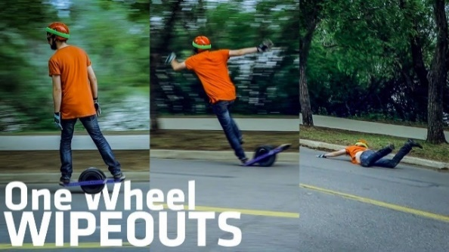
This picture shows the “I thought I was good at this, but I found out I actually really stink” type of failure
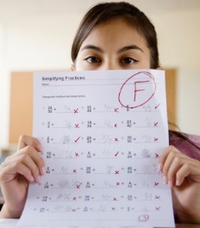
This picture shows the “I pretended it’d be okay, but I knew deep down it wouldn’t” kind of failure.
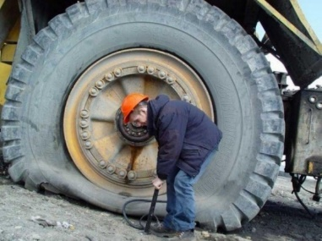
Here’s a picture of the “bad luck” kind of failure.
And my personal favorite, “just super, duper dumb” failure.
Can you think of other kinds of failure? Name a few.
We tend to enjoy others’ failures more than we enjoy our own. Most of the books and movies you love are about someone failing and then that same someone brushing himself or herself off and recovering. That’s true for Stanley Yelnats in Holes, for Darth Vader in Star Wars, for Ada in The War that Saved My Life, and for Scrooge in A Christmas Carol. Can you think of other characters—in movies or books—that overcome failure?
Now, how many of you are afraid to fail? Really really afraid?
What part of failing are you most afraid of?
Jeanne Ann is most afraid that her family’s failures will last forever.
But the truth is:
-Failure is almost never forever.
-The key to failure is recovery.
-Some of us recover on our own.
-Some of us need help to recover.
-Some of us who need help can’t find it or don’t want to ask...

Here’s a story about failure that’s not in PARKED but which influenced it.
One upon a time, there was a girl who did really well in school. Really really well. Give her a test or something to memorize, and she could outperform anybody. But, when she was twenty-four, she decided to go to cooking school. No books, no memorization. Just knives and flames and butter.
This girl decided to try cooking school because she really liked food. I mean, she really liked it. Pesto was her favorite. Followed by sourdough bread. And pineapple upside-down cake. Mostly, she liked eating food. But she liked cooking it, too.
But the cooking she’d done at home had not prepared her for cooking school. She was—by far—the worst student in her class.
I mean this girl REALLY stank. Here’s a picture of her, trying to look like she knows what she’s doing.
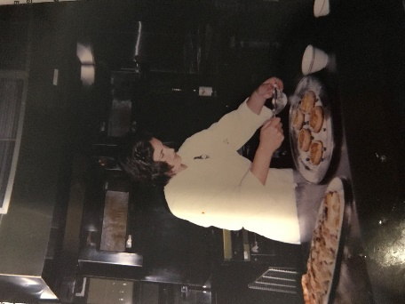

One day, the class had a timed test. The teacher gave everyone a basket filled with food and said, “You have three hours to turn everything in that basket into a delicious three-course meal. Go!” It was sort of like that TV program The Great British Baking Show. Have you seen it? Well, the girl got very frazzled and ended up serving undercooked chicken, a cheese-and-egg pie called quiche that melted into a greasy puddle, and a raw apple in a bowl, because she didn’t have enough time to bake it.
It was this kind of failure…

—but with a human instead of a dog.
But that’s not even the worst of it. The cooking school had some amazing teachers. This woman, Julia Child, taught the students how to make omelets.
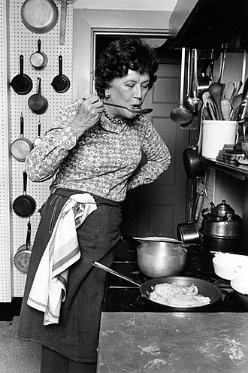
And this man, Jacques Pépin, taught the students how to cook all the parts of a turkey:
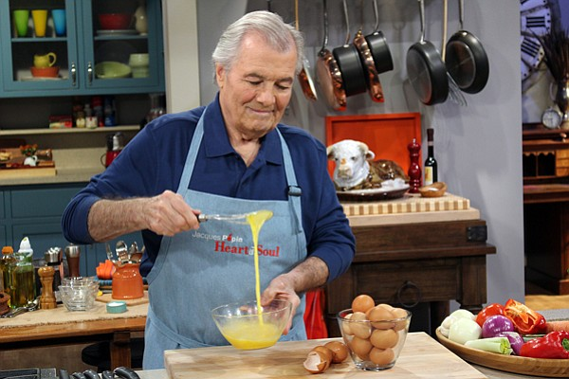

Do you know these names or recognize their faces? They are on TV a lot. They are two of the most famous chefs of the last hundred years. The girl in the cooking class felt so lucky to meet them, and, at the same time, so afraid they would find out she was the worst student in her class.
One of them definitely found out…
When Jacques Pépin came to guest teach, he randomly chose the very bad student to be his assistant during a class demonstration. He was preparing something called turkey fricassee, which is basically all the garbage parts of a turkey—the back, the neck, the wings—made into a delicious stew. While he was demonstrating to the class how to make this stew, the very bad student was supposed to be at the stove, stirring. And she did stir. And stir. And stir. And stir. But the stew was really boiling and sticking to the pot, and the girl kept trying to tell Jacques—with hand signals and raised eyebrows—that she thought it was getting overcooked. But he kept interrupting her, popping bits of food in her mouth, joking with the other students in his French accent. He didn’t care about the very bad student’s struggles at the stove. Finally, the girl just couldn’t take it anymore. She snuck out of the demonstration kitchen when Jacques wasn’t looking, and she hid in the back room. A few minutes later, she heard someone shout: “The fricassee is on fire! The fricassee is on fire!”
The stew had caught fire. And it was all her fault. Jacques was furious. She stayed in that back room until Jacques and every student went home.
Her food failure didn’t end there. The same very bad student got a job at an extremely famous restaurant in Berkeley, California, after she finished cooking school. But, on her second day at the job, while she was washing the sand out of mussels and chopping onions, the head chef walked up to her and said, “You! You talk too much, you move too slow. Time is money, space is money.”
The girl went home that afternoon feeling like a total failure. She’d been fired on her second day! What a waste of time and energy. How embarrassing. She moped around the house for days. Now what was she going to do? She needed to earn money to pay her rent. Luckily, the girl had a family that didn’t think this failure was such a big deal. They were the girl’s safety net. They said, “Buck up, kid. You will crawl out of this hole. We’ll be here to make you if you don’t.” It was their special brand of cheerleading. This is what her family sorta looked like:
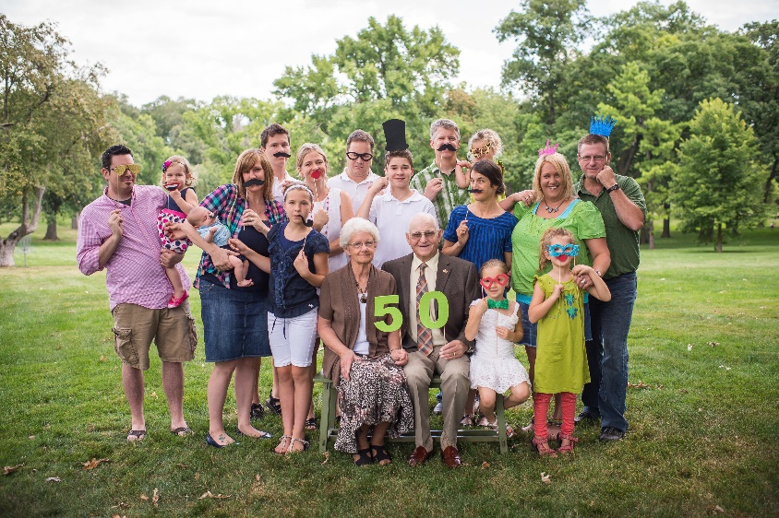

And their help saved her. Knowing they were watching, the very bad cook crawled out of her hole. The family waited patiently while she became a writer and a literary agent instead of a cook. It took a few years. But she did it.
And here I am. The girl who undercooked a chicken and burned a turkey fricassee and got fired after two days on a job—that was me. I recovered because I had a safety net—my family—that allowed me to fail and recover.
Why am I telling you this?
See the pots and pans hanging from the ceiling of the van on the cover of PARKED?
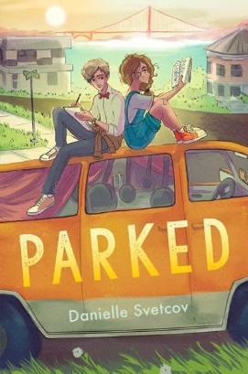
Jeanne Ann and her mom have lugged them all the way from Chicago to San Francisco, because Jeanne Ann’s mom is a great cook and wants to become an even better one in San Francisco. She wants to open a restaurant. She’s a way better cook than I will ever be. But, unlike me, she and Jeanne Ann don’t have a family of cheerleaders to catch them when they get into trouble and run out of money and confidence. They just have each other. And their pride. And, maybe, it’s not enough. Maybe they’ll accept Cal’s help (if he stops trying so hard, for the wrong reasons). Maybe they’ll allow themselves to accept kindness from others, too. You’ll have to read the book to find out…
Okay, I’ve reached the end of my note to you. Here are a bunch of questions to answer:
- Is a van a home? Why or why not? Here’s another way to phrase the question above: What things could you absolutely not live without and could a van contain them all?
- Where do you feel most comfortable and safe in the world? Why?
- If you were quarantined in a van instead of a house, what do you think it would feel like?
- Jeanne Ann and her mom eat a lot of peanut butter. How many small meals can a person get out of a jar of peanut butter—if the jar contains 454 grams of peanut butter and a small meal is 66 grams?
- In many parts of the country, it’s cheaper to park a car and live in it than it is to rent or own a home. True or false: you could afford to buy the square-foot of floor you’re sitting on right now, with money in your piggy bank. Research to see if you’re right.
- Cal keeps an eye on the whole neighborhood. He makes some assumptions based on what he sees, and his assumptions are not always right. How many neighbors do you know by name or nickname, right on your block? List them. Have you made assumptions about them?

If you end up reading PARKED, here are a few more questions:
- On page 10, Jeanne Ann’s mom says they are moving to San Francisco for “dignity.” What does she mean and what prevents her from finding dignity once she arrives? What does dignity mean to you?
- Why do you think the book is written in two, first-person perspectives?
- On page 102, you’re confronted by a string of French words. They each describe a different kitchen job. What does this scene reveal about Jeanne Ann and Jeanne Ann’s mom?
- If you were a character in PARKED, would you be on the side of the Beautification Committee or Jeanne Ann and Cal? Why?
- Jeanne Ann regularly refers to the “no-place place.” What does she mean?
- List some of the secrets kept in this book (and who keeps them) and how they affect people and plot.
- Cal believes he can be a hero to Jeanne Ann. What’s complicating his hero’s agenda?
- Sandy made Jeanne Ann think he was just like her. Was that okay? Why or why not?
- Write the first chapter of the sequel…

That’s it. If you liked this reader’s companion to PARKED or just liked reading PARKED, send me a note and tell me. And, if you feel inspired to draw a picture of any scene from PARKED, I’d love to see that, too. I’m at www.daniellesvetcov.com. In the meantime, keep an eye on your neighborhood. It’ll be waiting for you when this quarantine is over.
Best, Danielle Svetcov

Photo credits: flat tire/cheezburger.com; dog in toilet/everythingfunny.org; Jacques Pépin/kpbs.org; Julia Child/Wikipedia and kpbs.org; Golden Gate Bridge/gagosian.com; F grades/girlslife.com; One Wheel/ YouTube.

